SNAP Software Pseudo-Code – Flowcharts

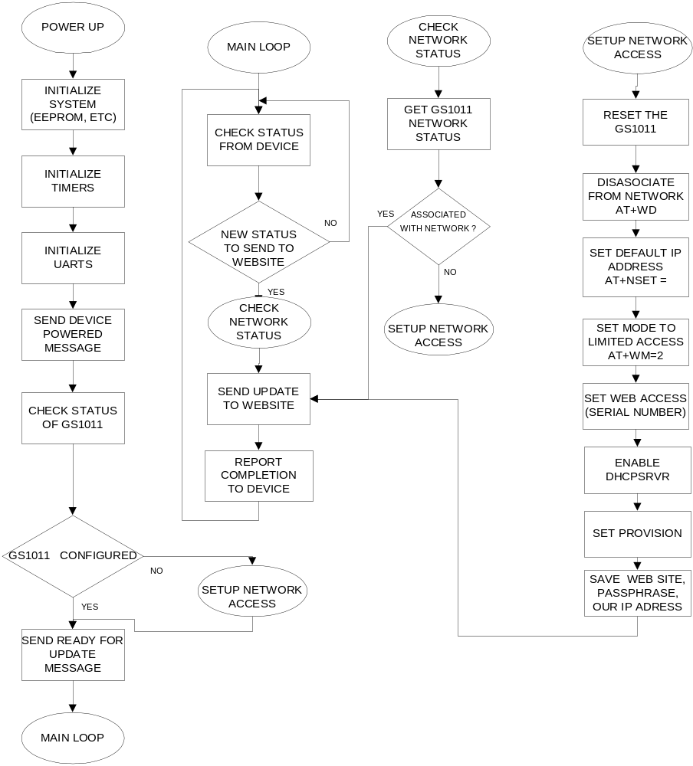
POWER UP / MAIN LOOP

- Initialize System
Check EEPROM for Web Access data, last device status.
If blank, set the Provisioning Needed flag.
- Initialize Timers
Set up a 10ms., and a 100ms timer (can be the same one).
- Initialize UARTs
Set both UARTs to 9600,8,1,none.
- Send “powered” to device.
- Check status of the GS1011.
If GS1011 connected, send ready for update to device.
If GS1011 needs configuring, send configuring message to device.
Configure the GS1011, when configured
Send ready to update to device.
- Perform check loops (Main Loop)
  - Check for status from device.
    - If update data available then
      - Check network status (setup network if necessary)
      - Send update to website
      - Get status back from website.
        - If there an action for device, send change parameter message.
        - If not just send status ok message.

CHECK NETWORK STATUS
- Get GS1011 network status (send AT+NSTAT=?)
  - Check if WSTATE – CONNECTED
    - If NOT CONNECTED then
      - Setup network access.
      - Then proceed to CONNECTED
    - If CONNECTED then
      - Lookup the websites IP address (AT+DNSLOOKUP = mars.bwgrp.com)
        - Save the Mars IP address.
      - Set the Mars website as the host (AT+HTTPCONF=11)
      - Set the Mars website to stay connected (AT+HTTPCONF==3, keep-alive)
      - Open a connection to the website (AT+HTTPOPEN=Mars IP Address).
        - Save CID (between 0 and 9)
      - Convert the update message to all ASCII, and assemble message.
      - Send the message to the website (AT+HTTPSEND=CID,1,100,”UPDATE MESSAGE).
      - Wait for response from GS1011.
      - Send ACK to device.

SETUP NETWORK ACCESS
- Create a Limited Access Point
  - snd a factory reset (AT&F,AT&W0,AT&W1,AT&Y0)

  - Reset the adaptor (AT+RESET)
  - Set initial IP address (AT+NSET=192.168.1.1,255.255.255.0,192.168.1.1)
  - Send setup web limited access mode (AT+WM=2)
  - Send web access name (AT+WA=”serial number”
  - Send DHCP server mode to 1 (AT+DHCPSRVR=1)
  - Set provisioning (AT+WEBPROV=,,,2,,1)
  - Wait for GS1011 to be configured with a router.
  - Save the name and pass phrase for the router.
  - Save our IP address.

